

AGRICULTURAL CLIMATE SOLUTIONS
ON FARM CLIMATE ACTION FUND

2026-2027
ACS-OF 2-21
APPLICATION GUIDELINES
February 2024
June 1, 2022

OFCAF 2-21 Program Application

Step 1 - Applicant Contact Information (Communication and disbursements will be addressed to applicant name)
Applicant (Farm Name or Individual Name) | Applicant Contact Information is prepopulated with information from your registration.  All registrations must include; An answer to the following question from the Registration form is required to be eligible for an OFCAF contribution.  Do you identify with any of the following underrepresented groups?  Indigenous Women Visible Minority Youth(under 40) LGBTQ2 Decline to Identify
Contact Name
Email |  | OFCAF Client Number:
City/Town
Province | NB Postal Code | County: NB COUNTY not CANADA
Registered Agricultural Producer Number:

Step 2 – Project Cost and Work Plan
Use the area below to summarize project costs and amount of contribution requested.
NOTE: Applications for georeferenced soil sampling with mapping completed in the Nitrogen Management Appendix must include a specific nitrogen, cover cropping or rotational grazing BMP activity on the same fields as sampled or mapped.
Gross Farm Income: □ less than $10,000 □ $10,000-$49,999 □ $50,000-$99,999 □ $100,000-$249,999 □ greater than $250,000
Budget Items | Estimated Cost of BMP Element | “Other Source” Contributions  (name, amount | $ Requested from OFCAF | Proposed Work Plan
 |  |  |  | Start Date | End Date
A. Nitrogen Management
- develop a multi-year N based nutrient management or annual N fertility plan
- georeferenced soil sampling with VRA mapping
- regular nitrogen fertilizer and inhibitor price difference
- certified or common seed and planting cost to increase legumes in rotation
- offsetting higher cost of synthetic fertilizer substitutes (manure, compost, digestates)
- fertilizer application equipment upgrades to allow banding, side dressing and injection
- cost of split nitrogen application
- transitioning to better manure management, cost associated with manure handling equipment to enable shallow incorporation
- polymer coated nitrogen fertilizer price difference
NITROGEN BMP TOTAL
B. Cover Cropping
- develop a cover cropping rotation plan
- purchasing certified or common seed of recommended cover crop species
- Cost of planting (tillage and seeding)
COVER CROPPING BMP TOTAL
C. Rotational Grazing
- develop grazing management plan & engineering plans
- grazing infrastructure (fencing & equipment, virtual fencing, installation, piping & renewable energy water systems)
- purchasing certified or common seed of recommended legume and grass pasture mixtures and cost of seeding for improved pasture composition
ROTATIONAL GRAZING BMP TOTAL
Total OFCAF Amount Requested (Less HST)
Step 5 - Additional Information
All applications must include a georeferenced aerial photo map with farm and field identification or georeferenced field location polygons. ArcGIS shape (shp) files are available from service providers (consultants, lime and fertilizer spreaders, JD Operations Center. KMZ files can be digitized and exported from Google Earth Pro. Refer to program guidelines for specific additional required documentation or contact the NBSCIA OFCAF Administration (ofcaf.facf@nbscia.ca) or your local NBSCIA coordinator for assistance. Hard copy OFCAF applications are available from the NBSCIA OCAFA Program Administrator.

NOTE: All applications must include the appropriate OFCAF Program BMP Appendix document(s) listed below to support your request for a contribution.
- Nitrogen Management
- Cover Cropping Management
- Rotational Grazing Management

TERMS AND CONDITIONS
- The Applicant acknowledges that the decision of NBSCIA as to entitlement to an amount of funding by contribution, if any, is final and binding and without right of appeal or review by the Applicant.
- The Applicant acknowledges and understands that the Applicant must disclose in this application for project funding, all proposed sources of funding, including sources and amounts from federal, provincial or municipal governments, conservation groups, and private organizations, including in-kind contributions, for the duration of this project.
- The Applicant acknowledges and understands that failure to comply with all the program requirements may delay processing the application or render the Applicant ineligible for financial assistance under the program.
- The Applicant will allow the NBSCIA to visit and/or photograph the project site for monitoring or promotional purposes. The NBSCIA will obtain permission from the Applicant prior to any such activities and these activities will not interfere with property operations.

Declaration and Signature
The applicant certifies that the information and representations contained in this application are true and correct to the best of his/her/ its knowledge and belief.
The applicant hereby gives his/her/its consent to the NBSCIA employees, agents, successors and assigns of NBSCIA to seek and obtain further and other information to whatever extent and from whatever sources or records as may be deemed or considered appropriate.
The applicant consents to the disclosure of applicant contact and project information to Canada for disclosure of financial, investment and qualitative information related to the funding of a project. Financial information disclosed may be for funding under a priority area, activity area and recipient type. Contribution information may be disclosed for the purpose of analyzing impacts of Government of Canada investments in the sector. Qualitative information may be disclosed to evaluate the results achieved from spending on programs under OFCAF.
The applicant consents to Canada publishing the amount of funding the applicant has received under the Agricultural Climate Solutions – On-Farm Climate Action Fund.
Applicant Signature Typing your name and electronically sending this form constitutes your electronic signature | DATE
Completed applications can be submitted as follows:
✓emailed to: ofcaf.facf@nbscia.ca
✓mailed to NBSCIA OCAFA Program Administrator,150 Woodside Lane Unit 2, Fredericton NB; E3C 2R9

OFCAF 2-21 Application Appendix A: Nitrogen Management
Applicant Information
Applicant (Farm Name or Individual Name): | Applicant Contact Information is prepopulated with information from your registration
Contact Name:
Email: |  | OFCAF Client Number:
Phone Number: |  | Cell Number:
Address:
City/Town:
Province: | NB Postal Code: | County: COUNTY not CANADA
Number of Livestock by Type: □ None □ Dairy □ Beef □ Sheep □ Other (Please specify) ____________

Step 1 SITE PLAN
Provide a georeferenced aerial photograph showing the field identification and location. Georeferenced farm and field locations emailed to ofcaf.facf@nbscia.ca ArcGIS shp file or Google Earth Pro KMZ polygon format are preferred. ArcGIS shape (shp) files are available from service providers (NBSCIA, consultants, custom lime and fertilizer spreaders, JD Operations Center, etc). KMZ files can be digitized and exported from Google Earth Pro. https://www.youtube.com/watch?v=-2sRYiwqzDs
Insert or Attach as Separate Page if Necessary
Field names or IDs must match with those in sections a,b,c,d,e,f,g,h,and i below. If you have received funding for the fields previously from OFCAF , be sure to use the same field IDs
Step 2 – Nitrogen Management Project Plan and Cost Worksheet
It is recommended that you discuss plan with a BMP Program Advisor prior to applying.
Current practices: Describe your current nitrogen management practices used. (e.g., rotation, nitrogen sources and management practices, legume and manure credits)
In addition to the general description of the current practice for each nitrogen BMP, include the specific application rates in lb per acre of land area in relation to crop requirement. Already asked for, just haven’t demanded it.
If transitioning to better manure management by purchasing equipment, calculate manure production = Number of Animals x Average Weight of Animal (lb) ÷ 1000 (animal unit) x Daily Manure Prod. x Manure Collection Period (days) + Estimated Percent of Bedding in Manure. [See Table Below]
Volumes should align with the application rates in the attached spreadsheet to calculate agronomic balance for the nitrogen requirement.

Average Daily Manure Production per 1000lb Animal Unit
Animal Type | Daily Production | Animal Type | Daily Production
Dairy Cow |  | Swine
Lactating (liquid) | 13 gal | Gestation | 4 gal
Lactating (solid) | 106 lb | Lactation | 10 gal
Dry | 82 lb | Nursery | 14 gal
Calf and heifer | 87 lb | Grow-finish | 11 gal
Beef cattle |  | Farrow to feeder | 7 gal
Cow and calf | 60 lb | Sheep | 40 lb
Steer | 75 lb | Horse | 45 lb
Veal | 5 gal
Add 5% for bedding to the manure value.

Improved nitrogen management practices: Describe the new practices that will be adopted, and how they are intended to improve nitrogen use efficiency and reduce nitrogen loss in terms of the following applicable nutrient management themes. *Refer to spreadsheet to estimate nitrogen requirement or provide a reference.
Source (e.g., controlled release, legumes, manure management):
Brand of polymer coated nitrogen.
Identify specific product brands and nitrogen contents.
In addition to the general description of the new or reduced practice for each nitrogen BMP, include the specific application rates in lb per acre of land area in relation to crop requirement.
For manure, compost and digestates provide an estimate of the reduction in synthetic nitrogen applied and emission reduction with incorporation.
Provide estimates of Synthetic Nitrogen Fertilizer Substitutes (manure, compost, digestates) spreading costs
Inhibitors must include both urease and nitrification products- Dicyandiamide + N-(n-butyl) thiophosphoric triamide (NBPT). Inhibitors and PCU products cannot be applied on the same field area.
Timing (e.g., split application, foliar application):
Define split or other applications relative to the crop growth stage.
Include specific application rates in lbs per acre in each split application In addition to the general description of the new practice for each nitrogen BMP, include the specific application rates in lb per acre of land area in relation to crop requirement
Include general dates of time of application relative to crop growth stage.
Nitrogen Rate (Current and Reduced):  - Nitrogen fertilizer and inhibitor price difference  - Seed and Planting Costs to Increase Legumes  - Offsetting Higher Cost of Synthetic Nitrogen Fertilizer Substitutes  - Fertilizer application equipment upgrades to allow banding, side dressing and Injection  - Cost of split nitrogen application  - Transitioning to better manure management, cost associated with manure handling equipment to enable shallow incorporation  i) Polymer Coated Nitrogen Fertilizer Price Difference | Current Practice  LBS/Acre | Improved/Reduced  LBS/Acre

a) Agronomic services to develop a multi-year N based nutrient management plan or an annual fertility plan |  | Total Area (ac.) | Estimated Service Cost
Service Provider:
Service Provider
b) Georeferenced soil sampling and VRA mapping |  | Total Area (ac.) | Estimated Service Cost
 | Sampling Type (grid, SoilOptix etc.) & Rate
Service Provider
Service Provider
Applications for soil sampling and mapping must include the adoption of an additional specific nitrogen, cover crop or rotational grazing BMP.
If the applicant reports that the soil testing and soil mapping has allowed them to reduce N application on their farm, the following additional data points are required that will be used by AAFC to quantify the GHG impact of the reduction in N use on-farm:
1. Historical application rate of N fertilizer on the acres in question.
2. New application rate of N fertilizer on the acres in question (post soil test/soil map).
3. Hectares converted (must be the same acres).

c) Nitrogen Fertilizer Inhibitor Price Difference |  |  |  | *Refer to spreadsheet to calculate nitrogen requirement
Field Id(s) | Crop(s) | Total Area  (acres) | Total Nitrogen Required (T) | Regular Nitrogen Cost/T | Inhibited Nitrogen Cost/T. | Total Estimated Difference Cost/ac | Total Estimated Cost
Convert cost difference per tonne to cost per acres to estimate total cost per field and project
Quantity of fertilizer purchased must approximate the total quantity recommended per unit of land area by the agrologist or CCA and applied to the crop area to validate the claim for payment.
Nitrogen requirement balance from spreadsheet (yield x rate) should approximate a zero agronomic balance in the spreadsheet.

d) Seed and Planting Costs to Increase Legumes
Field Id(s) | Legume Species | Total Area  (acres) | Total Seed Cost/ac | Tillage Cost ($/ac.) | Planting Cost ($/ac) | Total Estimated Cost
Quantity of seed purchased must approximate the total quantity recommended per unit of land area by the agrologist or CCA and applied to the crop area to validate the claim for payment.
e) Offsetting Higher Cost of Synthetic Nitrogen Fertilizer Substitutes (manure, compost, digestates) *Refer to spreadsheet to calculate nitrogen requirement
Field Id(s) | Crop(s) | Total Area  (acres) | Total Nitrogen Required(T) | Total Substitute Nitrogen(T) | Regular Nitrogen Cost/T | Substitute Nitrogen Cost/T | Total Estimated Cost
Calculate the unit cost of nitrogen in the synthetic fertilizer substitute compared to the synthetic fertilizer recommended by an agrologist or CCA,
Nitrogen requirement balance from the spreadsheet (yield x rate) should approximate a zero agronomic balance.
Spreading and Incorporation Costs |  |  |  |  | Spreading $/ac | Incorporation $/ac
Application costs can be included but should be explained in Improved nitrogen management practices section above.
Same fields, crops and area as above.
f) Fertilizer Application Equipment Upgrades
Field Id(s) |  | Crop(s) |  | Total Area  (acres) |  | Describe present system and equipment and the planned upgrades |  |  | Total Estimated Cost
 |  |  |  |  |  | Make and model of existing equipment and describe the new equipment upgrade.
Applications for fertilizer equipment purchase or upgrade must include a specific nitrogen BMP (c, d, e, f, g, h, i) and the total area of all crops and the specific area for each BMP.
 |  |  |  |  |  |  |  |  | $
g) Split Nitrogen Application *Refer to spreadsheet to calculate nitrogen requirement
Field Id(s) | Crop |  | Total Area  (acres) |  | Tillage Operation ($/ac) |  | Spreading Operation($/ac) | Total Estimated Cost/ac | Total Estimated Cost
Quantity of fertilizer purchased must approximate the total quantity recommended per unit of land area by the agrologist or CCA and applied to the crop area to validate the claim for payment.
Nitrogen requirement balance from spreadsheet (yield x rate) should approximate a zero agronomic balance.
h) Manure Application Equipment *Refer to spreadsheet to calculate nitrogen requirement
Field Id(s) |  | Crop |  | Total Area  (acres) |  | Describe present equipment and improved method of manure incorporation |  |  | Total Estimated Cost
 |  |  |  |  |  | Make and model of existing equipment and describe the proposed method of incorporation with the new equipment [solid and liquid spreaders, discs, hoses or equipment for shallow incorporation to avoid volatilization.
Applications for manure equipment purchase or upgrade must include a specific nitrogen BMP (c, d, e, f, g, h, i) and the total area of all crops and the specific area for each BMP. to improve incorporation.
 |  |  |  |  |  |  |  |  | $
i) Polymer Coated Nitrogen Fertilizer Price Difference |  |  |  | *Refer to spreadsheet to calculate nitrogen requirement
Field Id(s) | Crop(s) | Total Area  (acres) | Total Nitrogen Required (T) | Regular Nitrogen Cost/T | PCU Nitrogen Cost/T. | Total Estimated Difference Cost/ac | Total Estimated Cost
Quantity of polymer coated nitrogen fertilizer purchased must approximate the total quantity recommended per unit of land area by the agrologist or CCA and applied to the crop area to validate the claim for payment.
Nitrogen requirement balance from spreadsheet (yield x rate) should approximate a zero agronomic balance.
Calculate cost difference in lb or kg per acre x number of acres to arrive a Total Estimated Cost.
FUNDING REQUEST
Please complete the table below with as much detail as possible. Attach any applicable quotes, engineering plans, etc. BMPs applied to a specific farm area prior to the Program are ineligible. Note, however, that an expansion of a BMP application on a farm area where these BMPs have not been previously employed is eligible. In the case of transitioning to better manure management, only activities that improve manure incorporation in the soil are eligible.
Project Expenses  Planning (e.g., nutrient management plan, including crop diversification plans to increase legumes and pulses in rotation; engineering or technical design work by a qualified professional); Soil testing and soil and VRA mapping; Use of nitrification and urease inhibitors; Use of soil organic amendments and synthetic fertilizer substitutes (manure, compost, digestants); Increasing legumes in rotations to account for N credit from legumes in subsequent crop; Split application of fertilizer with reduced rate as a result of increased crop use efficiency; (changing to application during crop development to better match plant needs and reduce nitrogen loss); Transitioning to better manure management with improved manure incorporation to avoid volatilization-- solid manure should be incorporated as soon as possible to avoid ammonia loss. | Supplier | Total Estimated Cost (less HST)
A. Nitrogen Management
- develop a nutrient management plan | Supplier quote required with application | $
- georeferenced soil sampling and VRA mapping | Supplier quote required with application | $
- regular nitrogen fertilizer and inhibitor price difference | Supplier quote required with application | $
- purchasing certified or common seed of recommended legume species from registered dealers listed by NBSCIA seed and planting cost to increase legumes in rotation | Supplier quote required with application | $
- offsetting higher cost of synthetic fertilizer substitutes (manure, compost, digestates) | Supplier quote required with application | $
- fertilizer application equipment upgrades to allow banding, side dressing and injection | Supplier quote required with application | $
- cost of split nitrogen application | Supplier quote required with application | $
- transitioning to better manure management, cost associated with manure handling equipment to enable shallow incorporation | Supplier quote required with application | $
- price difference between regular nitrogen fertilizer and PCUs | Supplier quote required with application | $
Nitrogen Management Total (less HST): |  | $
I declare that the information herein is to the best of my knowledge correct.
PAg/CCA Signature | DATE
:

OFCAF 2-21 Nitrogen Management Planning Work Sheet

OFCAF 2-21 Application Appendix B: Cover Crop Management
Applicant Information
Applicant (Farm Name or Individual Name): | Applicant Contact Information is prepopulated with information from your registration
Contact Name:
Email: |  | OFCAF Client Number:
Phone Number: |  | Cell Number:
Address:
City/Town:
Province: | NB Postal Code: | County: COUNTY not CANADA
  Cover Cropping Summary
  Please complete the table below with as much detail as possible. If more space is needed, applicants can provide this section on a separate page attached to the end of the application.
  Field ID(s): | Acreage: | Cover Crop:
  Total acres
  For technical services and per acre payments for cover cropping
  Project Expenses  (services) |  | Supplier | Estimated cost (less HST)
   |  |  | $
   |  |  | $
   |  |  | $
   |  |  | $
  Subtotal |  |  | $
  Subtotal x 0.75 |  |  | $
  Number of Seeded Acres |  | Cost per acre | Subtotal for Seeded Acres
   |  | $75 | $
  Total (Subtotal x 0.75 + Subtotal for Seeded Acres) |  |  | $
Number of Livestock by Type: □ None □ Dairy □ Beef □ Sheep □ Other (Please specify) ____________

Step 1 SITE PLAN
Provide a georeferenced aerial photograph showing the field identification and location. Georeferenced farm and field locations emailed to ofcaf.facf@nbscia.ca in ArcGIS shp file or Google Earth Pro KMZ polygon format are preferred. ArcGIS shape (shp) files are available from service providers (NBSCIA, consultants, lime and fertilizer spreaders, JD Operations Center, etc). KMZ files can be digitized and exported from Google Earth Pro. https://www.youtube.com/watch?v=-2sRYiwqzDs
Insert or Attach as Separate Page if Necessary
Field names or IDs must match with those in sections a, b, c. If you have received funding for the fields previously from OFCAF , be sure to use the same field IDs
Cover Cropping Plan
Use the following table to provide the information requested. Additional information can be attached separately and submitted with your application. It is recommended that you discuss the plan with a BMP Program Advisor prior to applying.
Current Standard Practice | Fields going into cover crops are new, and have not been cropped in 10+ years. Recently acquired by farmers to use for forage production
Describe your current rotation sequence and how the project will reduce GHG emissions and sequester carbon.
Rationale for Cover Crop Species | Cover crop will include 70% oats and 30% forage peas blend. Seeding date will be between June 10-15. Oats were chosen as an easy to establish cover crop, with high biomass. Peas will fix nitrogen. Cover crop will be terminated by mowing around August 5th.
Rationale should include timing and planting dates for species in multi-species mixes.
Rotational Fit | After the cover crop is terminated, a forage grass mix with fescue, alfalfa and/or clover will be planted
Explanation should include seeding dates and compatibility with other seasonal farm operations.
Machinery Implement/Method of Establishment
The shank type and configuration should be described and estimated cover crop residue remaining over winter or after the tillage operation.
Requests for new equipment should clearly define the cost benefit in machine operation costs and timeliness of managing cover crops
Step 2 – Cover Cropping Project Plan and Cost Worksheet
a) Develop a cover cropping rotation plan (agronomic services) |  | Estimated Service Cost
Service Provider:
Service Provider

b) Cover Crop Seeding Plan
Field ID | Field Area (ac.) | Previous Harvested Crop | Current Year Main Crop | Cover Crop Species/Mix | Cover Crop Seeding Rate (lbs./ac) | Total Cover Crop Seed Required (lbs) | Total Estimated Seed Cost | Date of Seeding Cover Crop | Date of Cover Crop Termination
Quantity of seed purchased must approximate the total quantity recommended per unit of land area by the agrologist or CCA and applied to the crop area to validate the claim for payment.

c) Cost of Planting
Field Id | Total Area (ac.) | Tillage Operation ($/ac.) | Seeding Operation ($/ac.) | Total Planting Cost/ac. | Total Estimated Cost

FUNDING REQUEST
Please complete the summary table below with as much detail as possible. Attach any applicable supplier quotes, engineering plans, etc. BMPs applied to a specific farm area prior to the Program are ineligible. Note, however, that an expansion of a BMP application on a farm area where these BMPs have not been previously employed is eligible. Note that crops that will be harvested or grazed leaving less than 6 inches (15cm) of cover crop growth over winter and crops that can be harvested in the next growing season intended for market (e.g., winter cereals) are not eligible under this program. .
Project Expenses  Planning cover crops and rotations by an accredited professional, common and certified seed cost, from registered dealers as listed by NBSCIA OFCAF and cost of planting cover crops. | Supplier | Total Estimated Cost (less HST)
B. Cover Cropping
- develop a cover cropping rotation plan | Supplier quote required with application | $  $
- purchasing certified or common seed of recommended cover crop species from registered dealers listed by NBSCIA | Supplier quote required with application | $
- Cost of Planting (tillage and seeding) | Quote or estimate required | $
Cover Cropping BMP Total (less HST): |  |  | $
I declare that the information herein is to the best of my knowledge correct.

PAg/CCA Signature | DATE
:

OFCAF Application Appendix C: Rotational Grazing
Applicant (Farm Name or Individual Name) | Applicant Contact Information is prepopulated with information from your registration
Contact Name
Email |  | OFCAF Client Number:
Phone Number |  | Cell Number:
Address (Line 1)
City/Town
Province | Postal Code | County: COUNTY not CANADA
Number of Livestock by Type: □ None □ Dairy □ Beef □ Sheep □ Other (Please specify) ____________

NOTE: Forage Grazing Applications must include a georeferenced aerial photo map. Georeferenced farm and field locations emailed to ofcaf.facf@nbscia.ca in ArcGIS shp file or Google Earth Pro KMZ polygon format are preferred. ArcGIS shape (shp) files are available from service providers (consultants, NBSCIA coordinators). KMZ files can be digitized and exported from Google Earth Pro. https://www.youtube.com/watch?v=-2sRYiwqzDs

Step 1 –Describe Current System and Proposed Grazing Plan Improvements
DETAILS ON THE CURRENT GRAZING SYSTEM
Using a georeferenced aerial photo map, ArcGIS shp or Google Earth Pro KMZ polygons show the locations of the current grazing system.
Field names or IDs must match with those in sections a,b,and c below If you have received funding for the fields previously from OFCAF , be sure to use the same field IDs.
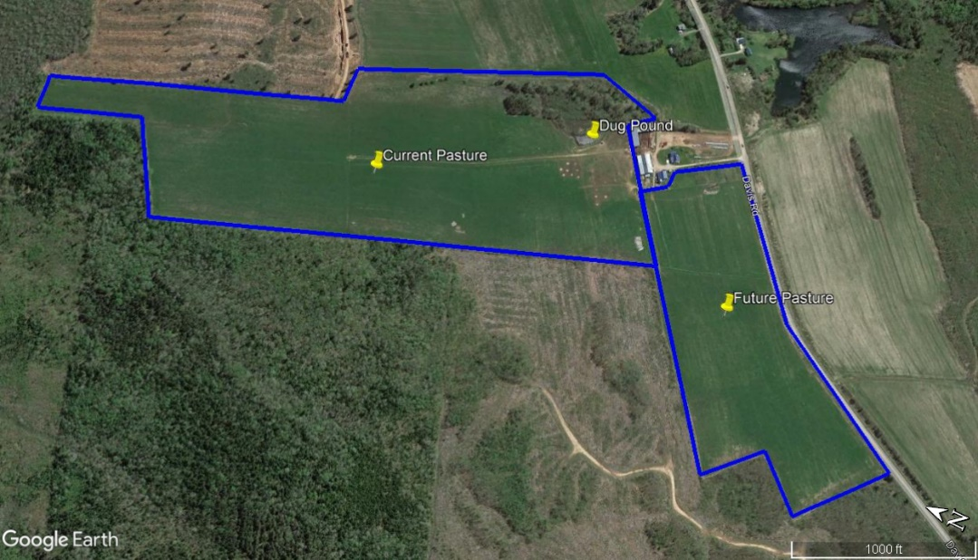
Insert or Attach as Separate Page if Necessary

Number of grazing head: ___Cows ___Calves ___Replacements ___Bulls ___Feeders ___Sheep ___lambs ___rams Other (Please specify) _________________________________________
Total Pasture Acreage: Current: New area to be added as part of this project: _____Total Pasture Area: ____
Number of paddocks: Current: Additional as part of this project: Total Number of Paddocks: ____
Describe the current grazing system: Use the space given or attach a summary/project proposal (1-2 pages) to the end of the application form if more space is required.

Overall pasture condition (excellent/good/fair/poor). Estimate species composition in % grasses (blue grass, fescue, timothy etc.), % legumes (white clover, trefoil, alfalfa, etc and % weeds (thistles, burdock, etc.)

Step 2 –Grazing Project Plan and Cost Worksheet

It is recommended that you discuss the plan with a BMP Program Advisor prior to applying.
DETAILS ON THE PROPOSED ROTATIONAL GRAZING PLAN
Using a georeferenced aerial photo map, ArcGIS shp or Google Earth Pro KMZ polygons show the locations and shape of the new paddocks you wish to implement, the water sources, access points, and other management features.

Field names or IDs must match with those in sections a,b,and c below If you have received funding for the fields previously from OFCAF , be sure to use the same field IDs.

Self-guided resources are available at: https://www.farmlearninghub.ca/courses/grazing-plans
Describe how you will be implementing the new improved rotational grazing practices. Note the size of each pasture, and any other descriptive pieces of information you know or observe. Please include any areas you wish to convert to pasture as part of this plan.
Insert or Attach as Separate Page if Necessary
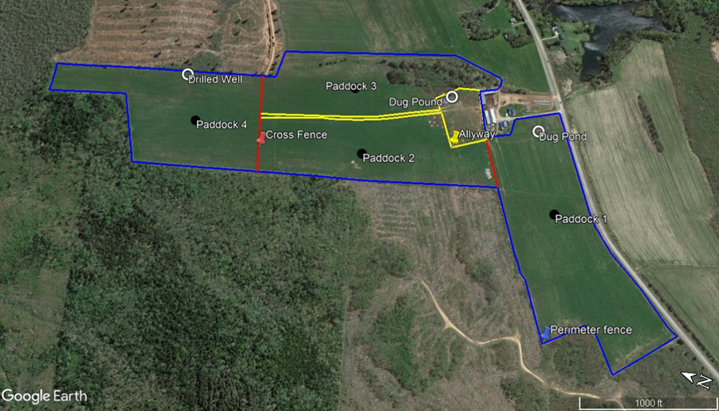

Improved Grazing Management Practices Provide a summary of the intensive grazing management system you will be implementing, and the management plan actions (including stocking density, length of grazing, etc.). Use the space given or attach a summary/project proposal (1-2 pages) to the end of the application form if more space is required
Paddock Id | Acreage | Forage Species  (Identify species variety and % of mixture) | Water Source(s) | Projected Grazing Period | Projected Rest Period | # Grazing Passes
Stocking Density Estimated target stocking density (number of animals per paddock area)
Timing of grazing and forage recovery
How long are animals in a paddock, and was is target forage recovery time?
Pasture Composition and Improvement Any planned improvements in pasture composition, and rationale for species selection.
Seed and Planting Costs to Increase Legumes
Field Id(s) | Legume Species and % legumes | Total Area  (acres) | Total Seed Cost/ac | Seeding Operation ($/ac.) | Total Planting Cost/ac. | Total Estimated Cost
Quantity of seed purchased must approximate the total quantity recommended per unit of land area by the agrologist or CCA and applied to the crop area to validate the claim for payment

FUNDING REQUEST
Please complete the table below with as much detail as possible. Attach any applicable quotes, engineering plans, etc. BMPs applied to a specific farm area prior to the Program are ineligible. Note, however, that an expansion of a BMP application on a farm area where these BMPs have not been previously employed is eligible
Project Expenses  Rotational grazing plan by an accredited professional; installation, interior cross fencing, perimeter fencing of newly developed pastures, wildlife-friendly fencing, temporary fencing, water infrastructure (waters, underground piping, remote systems powered by renewable energy, etc.), certified or common seed of recommended grass and legume pasture species and seeding cost | Supplier | Total Estimated Cost (less HST)
C. Rotational Grazing
- develop grazing management plan & engineering plans | Supplier quote required with application | $
- installation and purchase of grazing infrastructure (fencing & equipment, piping & renewable energy water systems) | Supplier quote required with application | $
- purchasing certified or common seed of recommended legume and grass pasture mixtures from registered dealers listed by NBSCIA and cost of seeding for improved pasture composition. | Supplier quote required with application | $
Rotational Grazing BMP Total (less HST): |  | $
I declare that the information herein is to the best of my knowledge correct.

PAg/CCA Signature | DATE
:

Source: Atlantic Grains Council- AGC custom rate survey. Published January 2023
Operation | Treatment | AGC Recommended 2023 Value  $/ac | NBSCIA 2025-2028  Recommended Work Rates  $/ac
 | Single pass | 36.30 | 45.75
Tillage | discing | 31.30 | 39.50
 | harrowing | 16.00 | 20.00
Fertilizer Spreading & Frost Seeding | Broadcast | 13.50 | 18.00
Spraying | Generic | 16.80 | 21.00
Grain Planting
 | Tilled | 30.60 | 38.50
 | No-till | 29.70 | 37.40
Soy Planting | Tilled | 32.00 | 40.30
 | No-till | 32.10 | 40.45
Corn Planting | Tilled | 33.00 | 41.60
 | No-till | 33.30 | 42.00
Harvesting with Combine | Grain | 61.10
 | Soybean | 61.70
 | Corn | 63.10
Corn Silage Harvesting |  | 54.00
Manure spreading |  | 38.00 | 47.80
Notes: 1. Fertilizer spreading and spraying does not include cost of product.
- Fertilizer and seed is not included in seeding costs for various crops.
- Grain buggies are included in cost of combining.
Source: NBSCIA adapted Atlantic Grains Council 2023 rates 2025-2028.

